Ideation Phase
Brainstorm & Idea Prioritization Template

Date | 31 January 2025
Team ID | LTVIP2026TMIDS88461
Project Name | DocSpot — Seamless Appointment Booking for Health
Maximum Marks | 4 Marks

Brainstorm & Idea Prioritization Template:
Brainstorming was conducted in a collaborative and open environment where all team members contributed ideas without immediate judgment. The focus was on generating a wide range of solutions before narrowing them down through structured prioritization.
We prioritized volume of ideas first, then grouped and evaluated them based on feasibility, impact, and alignment with project goals.
Step-1: Team Gathering, Collaboration and Select the Problem Statement

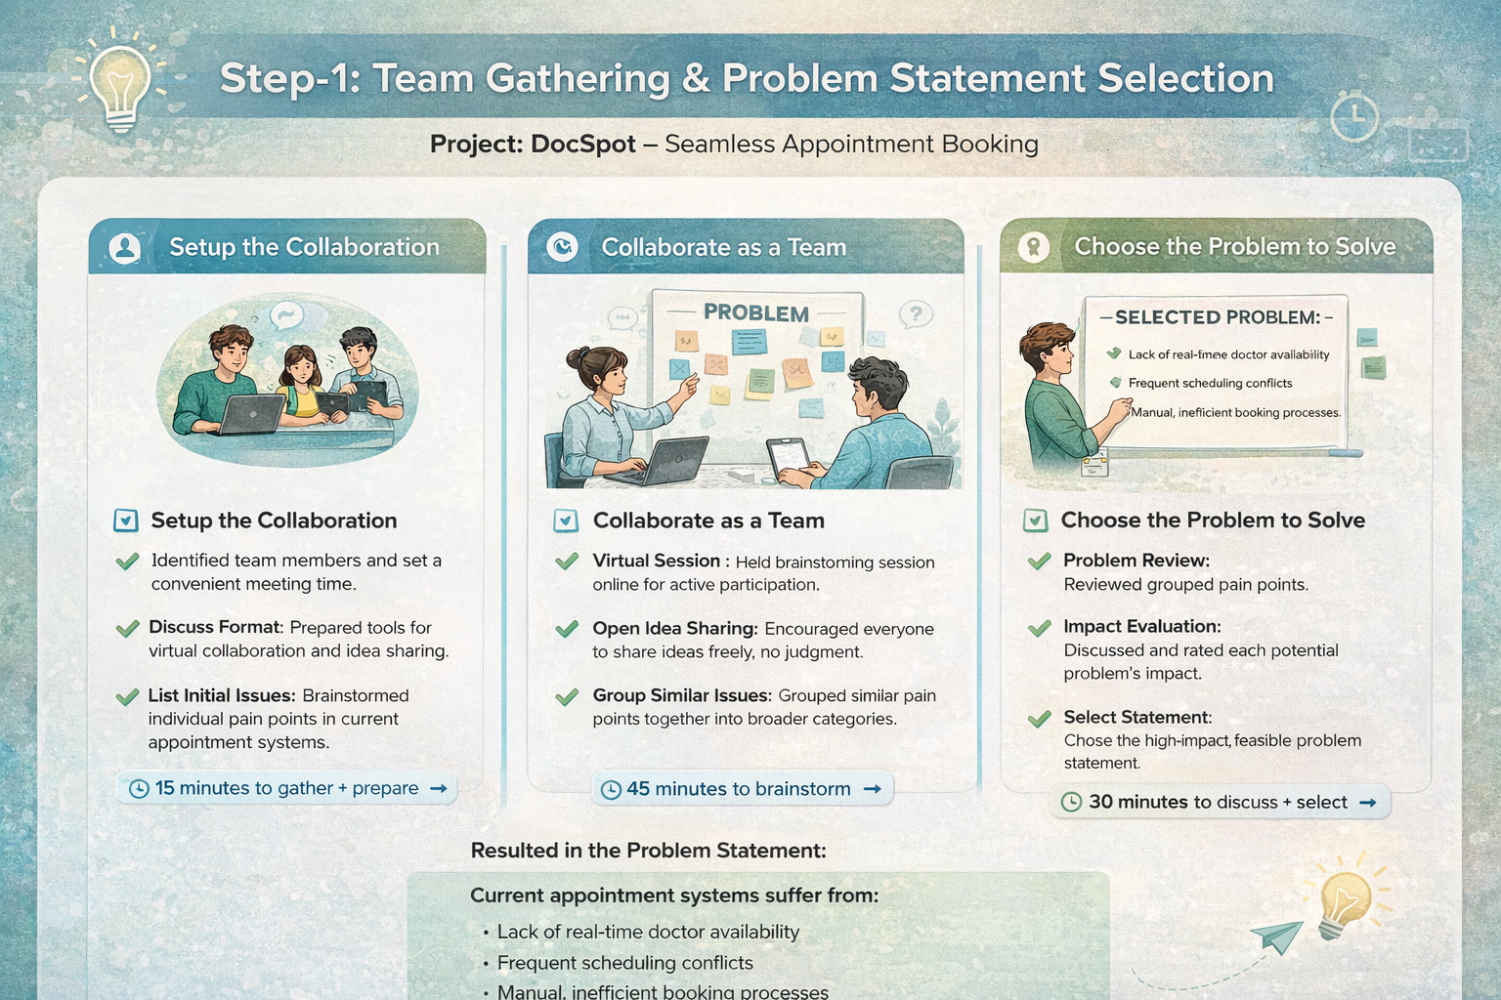
Step-2: Brainstorm, Idea Listing and Grouping

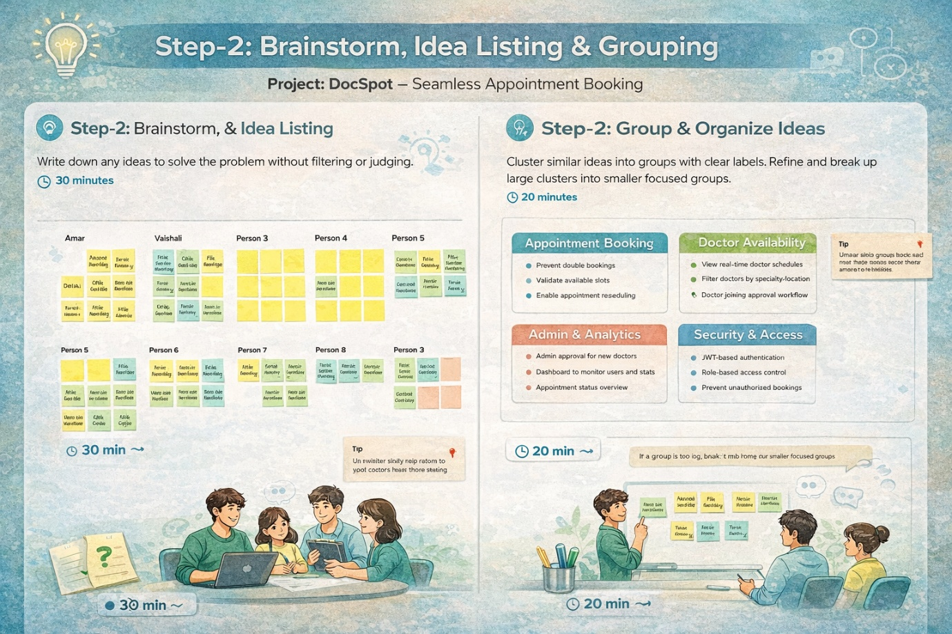

Step-3: Idea Prioritization

